Exercise - Create a new ASP.NET Core app

In this unit, you'll create, build, and run a new ASP.NET Core web application on your local machine. You'll need Visual Studio 2019 installed with the **ASP.NET and web development** and **Azure development** workloads installed.

**Create an ASP.NET Core project**

1. Open Visual Studio 2019 on your local machine.
2. From the Visual Studio landing page under **Get started**, select **Create a new project**.
3. In the search box, enter **Web**.
4. From the search results, select **ASP.NET Core Web Application**.
5. Select **Next**.
6. In the new project dialog, set the **Name** field to **AlpineSkiHouse**.
7. Select a **Location** for your new solution.
8. Select **Create** to create your project.

| **Note:** |
| --- |
| You can also select different starting templates in this dialog box depending on your web development requirements. At the top of the dialog box, you can also select the version of ASP.NET Core. You should select ASP.NET Core 3.1 or later. |

**Build and test on your local machine**

1. Now, let's build and test your application on your local machine before deploying to Azure.

| **Tip** |
| --- |
| Launching the app in non-debug mode allows you to make code changes, save the file, refresh the browser, and see the code changes. Many developers prefer to use non-debug mode to quickly launch the app and view changes. |

2. Visual Studio starts the IIS Express web browser and loads the app.

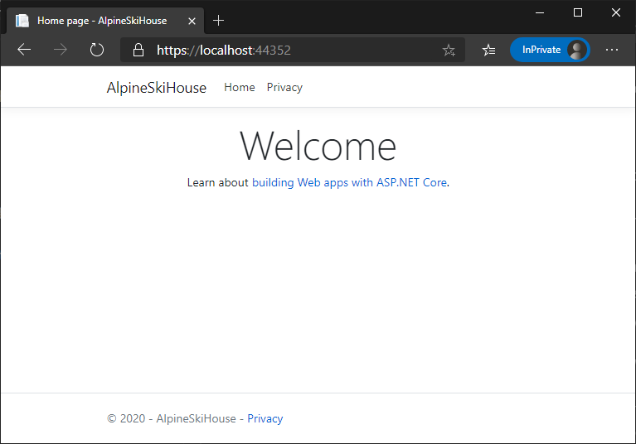The web app running in a browser.

When Visual Studio creates a web project, a random port is used for the web server. In the preceding image, the port number is 44381. When you run the app, you'll likely see a different port number.

| **Important** |
| --- |
| You might notice the section at the top of the web page that provides a place for your privacy and cookie use policy. Select **Accept** to consent to tracking. This app doesn't track personal information. The template-generated code includes assets to help meet General Data Protection Regulation (GDPR). |

You've now created a web application from the sample template and it's running locally. The next step is to deploy it to Azure.